# **Take and Make: Conic Sections Model**

Lauren Siegel

November 8, 2021

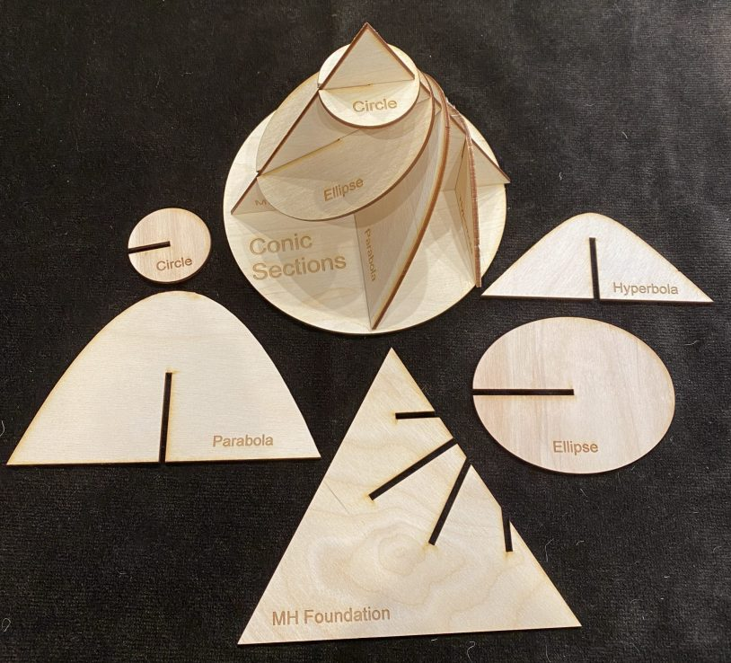

Turns out you can use CorelDraw to reverse engineer the parts to a conic section model. Read all about it in the [November 2021 MAA Math Horizon](http://digitaleditions.sheridan.com/publication/?m=53548&i=726840&p=28&ver=html5)s page called [Do The Math (p. 29).](https://drive.google.com/file/d/12AVFoilSZ3BNMwYdr7ggIMtyjiFGrDZu/view?usp=sharing)Editor Tom Edgar was fun to work with, and made the graphic images.

Note: if you are “making” this model from scratch, once you find the long and short axes of the ellipse, you could use the “trammel method” to find all its points. Here’s a [youtube on that](https://youtu.be/LEkfwttiWzw) by TechSquare

We cut ours out of 1/8″ wood so the slots are that size – you may need to adjust.

If you want a wooden model like this one we can send you one for free. [Please fill out this form and we will get back to you.](https://app.smartsheet.com/b/form/d55f3b9298f4417f82c38a25f0d0be9b)

If you are a district leader, or conference organizer in the US or Canada, who could distribute a dozen or more to teachers, library, etc, [please request a bulk shipment using this form](https://app.smartsheet.com/b/form/d4000bdf2bf4471cb2c2e61778f71ced).

[8.5×11 Printable PDF of original design](https://drive.google.com/file/d/1OgCg84WafY9v5HXpZRcouqnuBJ15OA9_/view?usp=sharing) (glue to cardstock instead of wood and cut out)

The exterior of the cone for the original design is a semi circle. You can make two quarter circles on 8.5×11 inch paper with radius equal to the side length of the triangle, tape them together and have a cone that fits.

To make from “scratch”:

Start with an isosceles triangle and then draw lines – across for circle, parallel to a side for the midline of the parabola, across at angle for ellipse and vertical (or not parallel to a side) for the hyperbola.  
Next use those lines to find the dimensions of the conic section pieces – diameter of the circle, the long and short axis for ellipse (use the chord at the base located a distance equal to the distance of the center of the ellipse to the midline of the triangle, parabola height (length of line) and width which is the chord where it intersects the base circle, and similarly for the hyperbola.)

Using this sequence we made [a pointier version as well in PDF 8.5 x 1](https://drive.google.com/file/d/16s8s2LmLLWLOhbbIszVqP2-QfuDgijQz/view?usp=sharing)1

The “wrap” for the pointy version is made from a portion of the circle with radius equal to the side length of the triangle. What part or fraction of that circle? Only as much as can contact with the bottom of the cone.

[Here’s a template for this one.](https://drive.google.com/file/d/10HSLwWdwP0rDFaaJ6zqYVhOhGOrwqM9U/view?usp=sharing)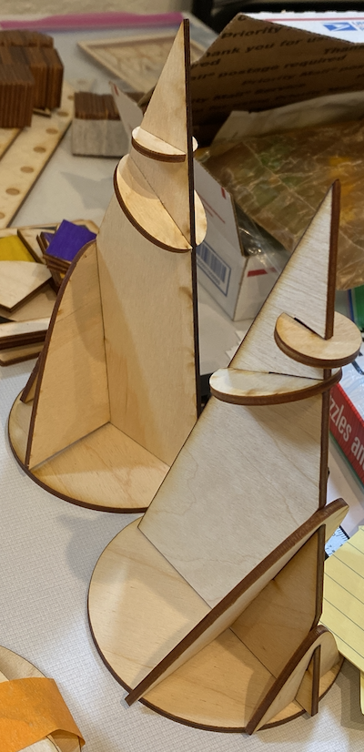

You can also slice Playdoh or clay to get a great conic section model. Sometimes those get squishy, but you can repeat and experiment with different cones.

See a video made by Paola Garcia explaining further here:

I made a few extras!

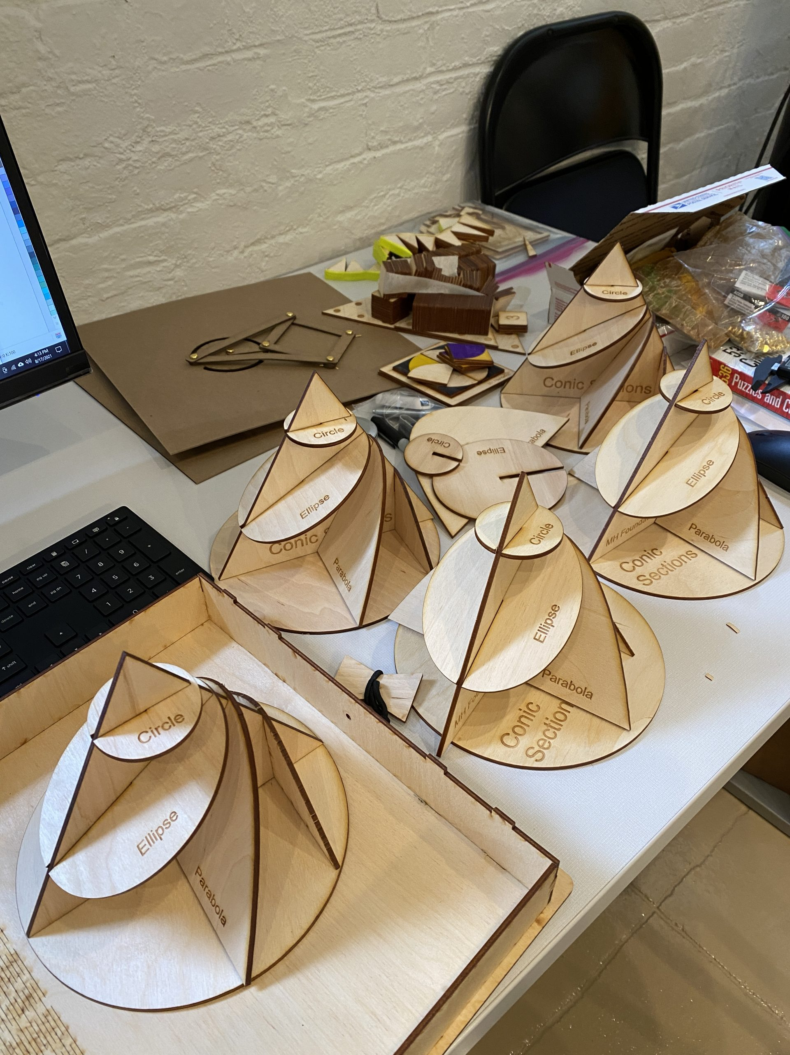

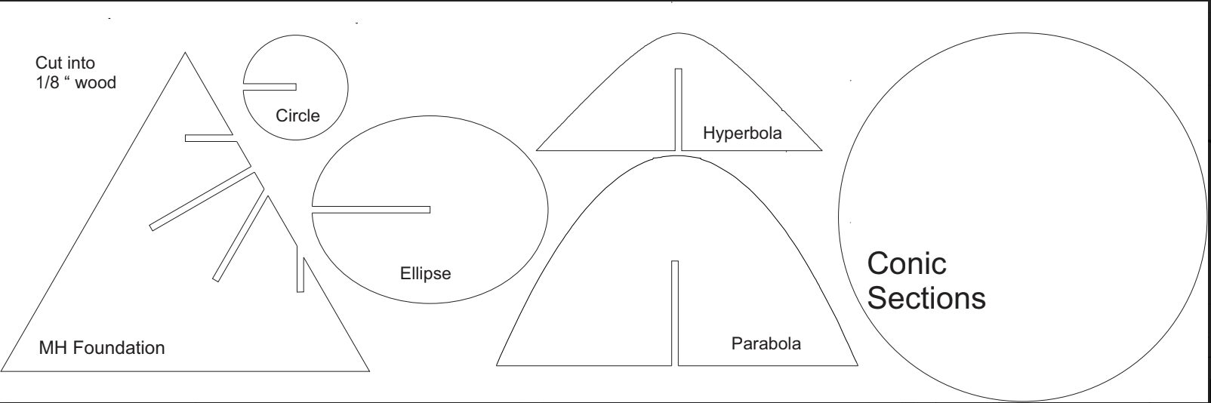

Here’s a Cricut and a foam version [posted to twitter by Mark Kaerscher](https://twitter.com/shskaercher/status/1428080763937992711?s=20)

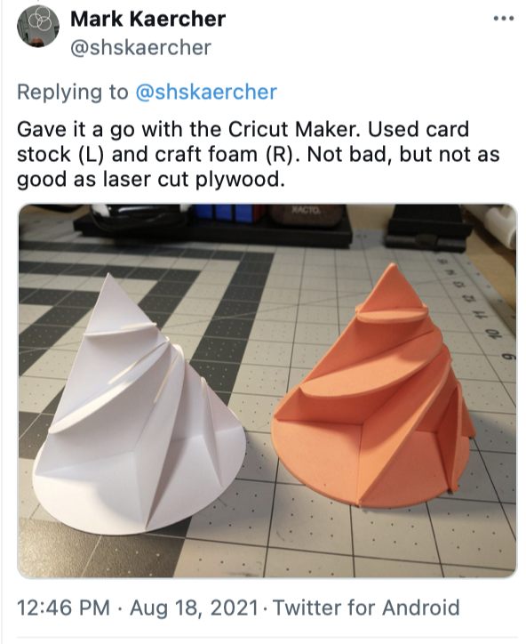

And a 3d Printed model by MathHappens board member Alex Siegel:

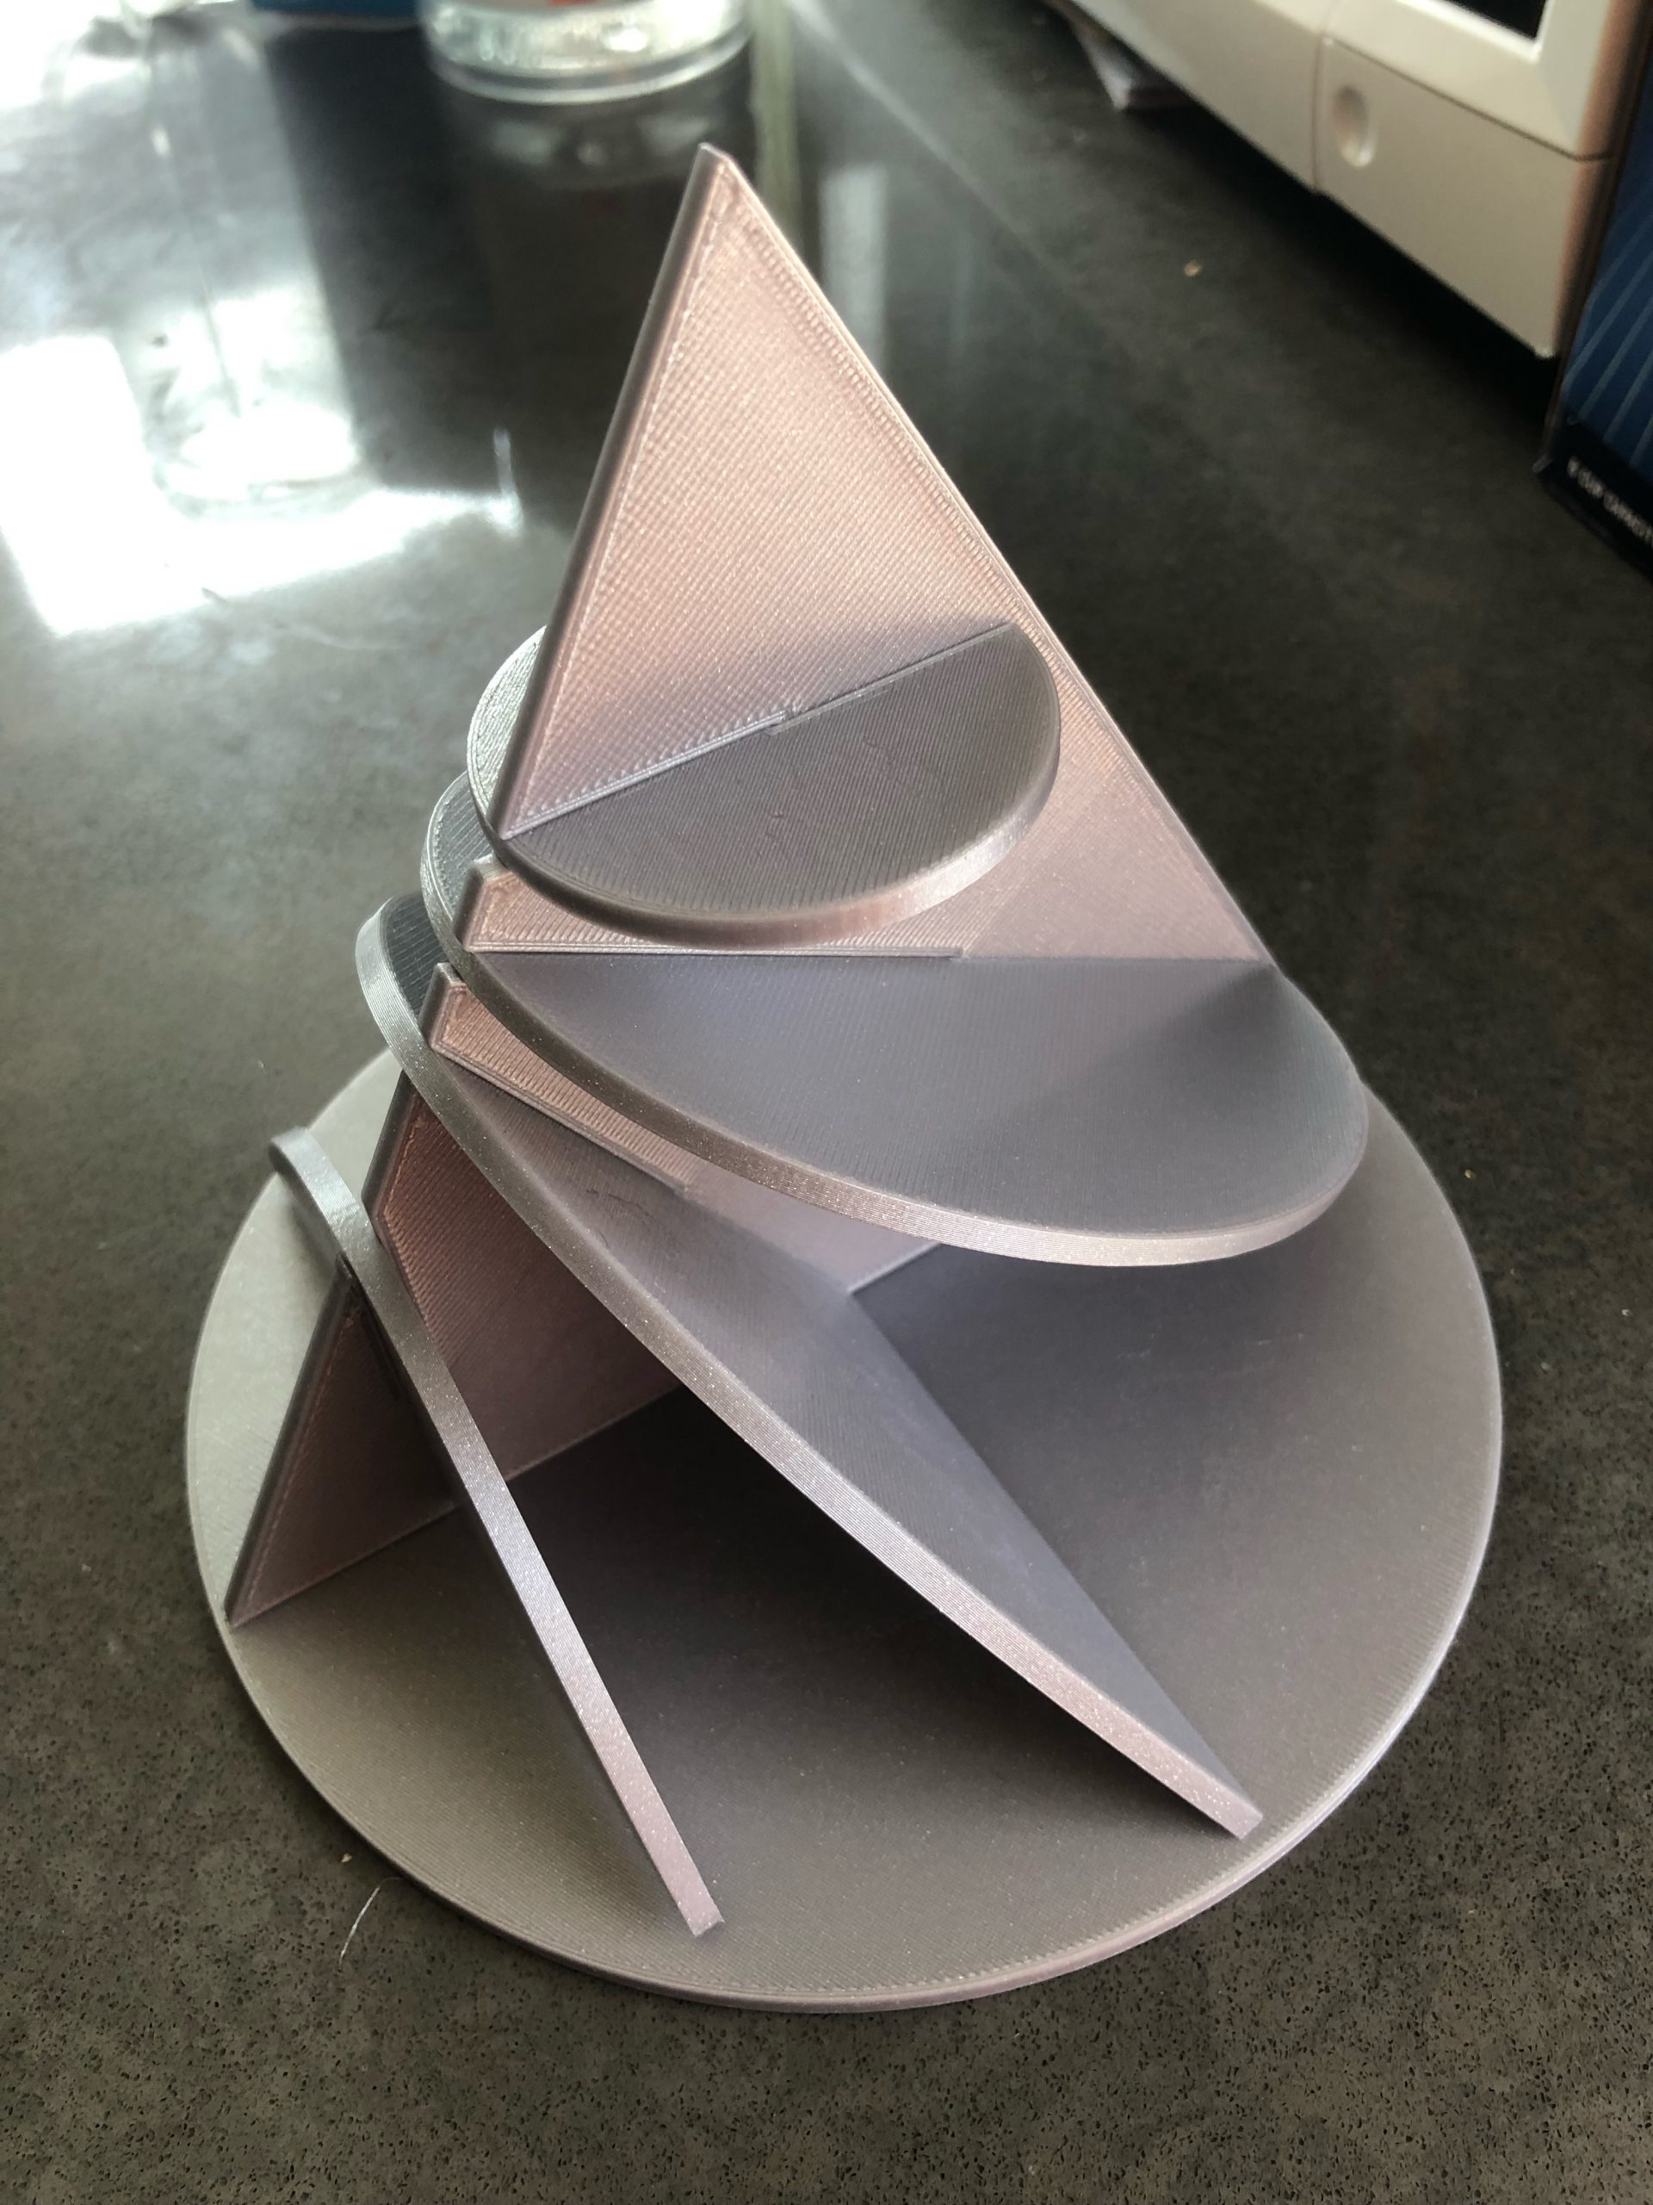

Folks are making their own versions with all kinds of materials and adding the shell is a great idea!

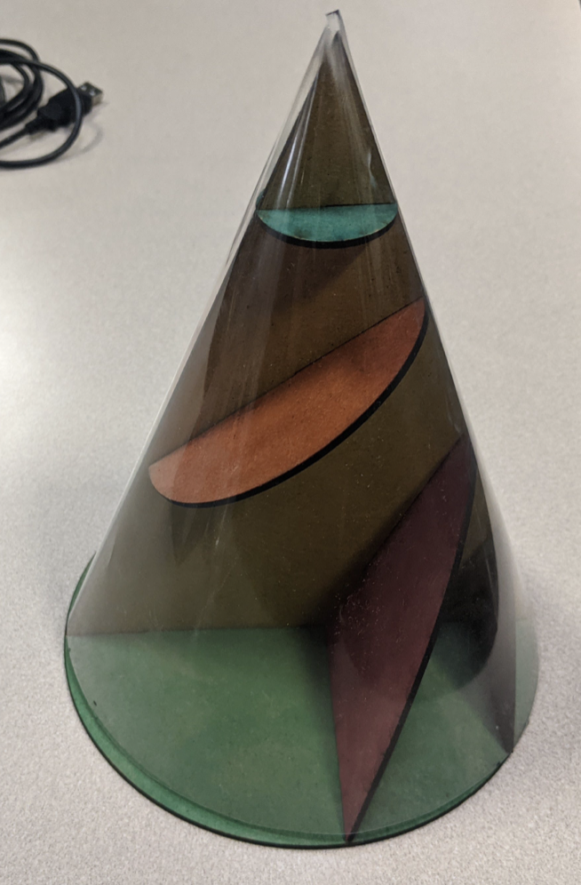

SOUTHBEND INDIANA

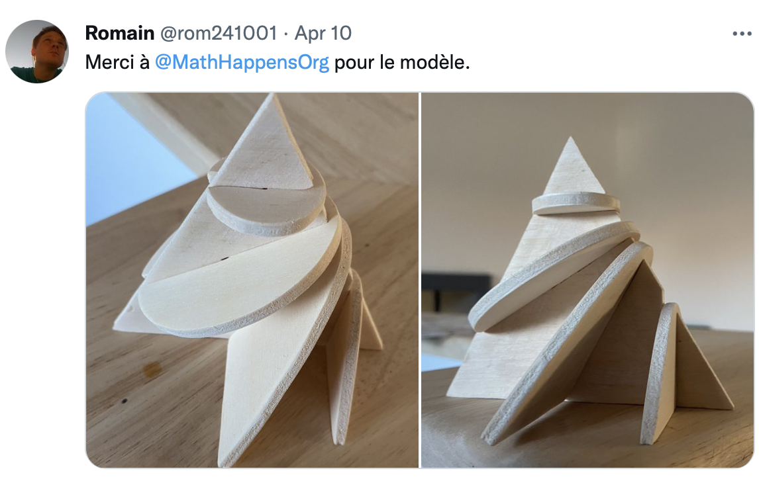

EASTERN FRANCE (NEAR SWITZERLAND)